S_ALR_87012284 -

Functionality
As part of the year-end closing, individual companies create financial statements according to country-specific regulations. SAP allows you to create the following financial statements:
Balance Sheet: Form of a comparison of assets and capital (liabilities and owner's equity). Assets and capital reflect the same total value.
Profit and Loss Statement: Comparison of revenue and expenditure of a period to determine the results for the company and the sources of these results
To generate the report, you need to define the Financial Statement Version that includes the BS and P&L structure and the required GL accounts.

Scenario
You want to generate a financial statement report for company code 5200 for a particular period of time.

Requirements
Define a Financial Statement Version.

Menu Path | Accounting → Financial Accounting → General Ledger → Periodic Processing → Closing → Report → General Ledger Reports → Balance Sheet/ Profit and Loss Statement / Cash Flow → General → Actual/Actual Comparisons → S_ALR_87012284 - Balance Sheet / Profit and Loss Statement
Transaction Code | S_ALR_87012284

1. Double click on S_ALR_87012284 - Balance Sheet / Profit and Loss Statement.

Balance Sheet/P+L Statement

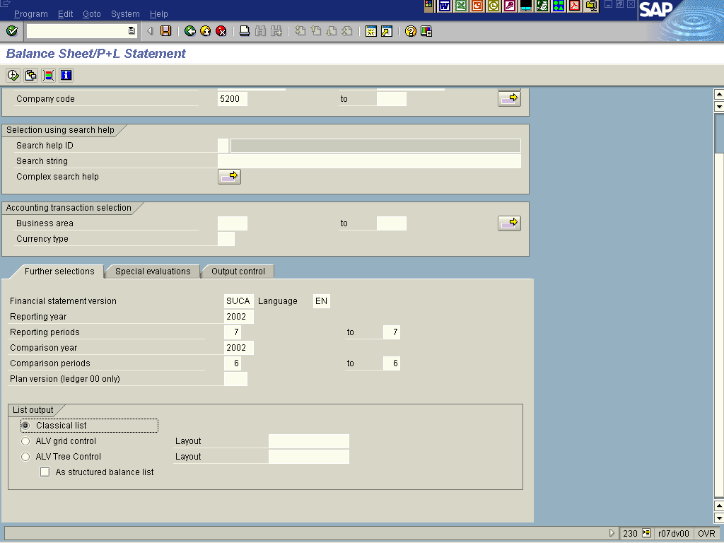

2. Update the following fields:

Field Name | Field Description | Values
Chart of accounts | A chart of accounts contains the G/L accounts. A chart of accounts must be assigned to each company code. This chart of accounts is the operative chart of accounts and is used in both financial accounting and cost accounting. | Example: SUCA
Company code | Enter here required company code number | Example: 5200
Financial statement version | Code identifying the type of report you need to display | Example: SUCA
Reporting Year | First fiscal year number | Example: 2002
Reporting periods | Enter here the required period. You can prepare a financial statement regarding one month or enter a range, e.g. Jan – July | Example: 7
Comparison year | Year against which to compare the reporting period profits | Example: 2002
Comparison periods | Fiscal period against which to compare the reporting period profits | Example: 6

 If you want to generate the Trial Balance, select TB variant in the field Financial statement version.

3. Click <radio button> Classical list .
Note: Now you can define your special requirements for this report (like choose the balance sheet type or decide whether to include in the report the accounts with zero balance).

4. Click <tab button> Special evaluations .

5. Update the following fields:

Field Name | Field Description | Values
Balance sheet type | This parameter controls which periods flow into the reporting and comparison period. The following entries are possible:  1: This means that an accumulated balance sheet is created, that is, the balance is calculated from the balance carried forward plus the periods 01 to the upper limit of the reporting and comparison periods you have specified.  The lower limit specified in these parameters is ignored in this case. Balance sheet accounts and P+L accounts are treated the same.  2: This means that a flow of funds analysis is created, that is, the balance is calculated from the reporting and comparison periods you specified.  The balance carried forward is not taken into consideration. Balance sheet accounts and P+L accounts are treated the same.  3: This means a combination of possibilities "1" and "2". Here balance sheet accounts are dealt with as described under balance sheet type 1, and P+L accounts as described under balance sheet type 2.  4: This means that an opening balance sheet is created. Here only the balance carried forward is used for the reporting and comparison periods. Accounts which have not yet been posted to or have a zero balance, are also displayed in this variant. | Example: 3

 It is recommended to select Balance Sheet Type number 3.

Balance Sheet/P+L Statement

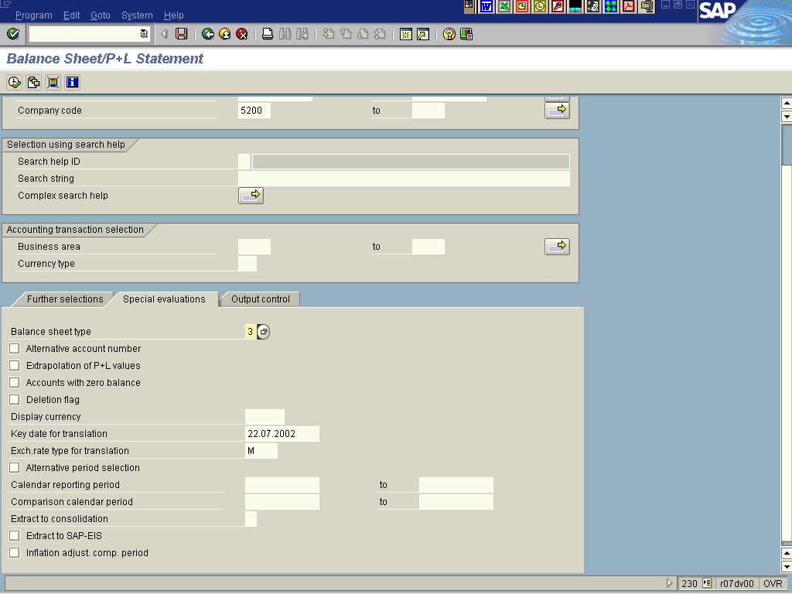

Note: You need to define the output of the report. For instance, you can determine the level of detail of the balance sheet and P+L via your entry in the "Summary report" field.
6. Click <tab button> Output control .

7. Update the following fields:

Field Name | Field Description | Values
Company code summarization | The following entries are possible:  1 = A balance sheet is created per company code  2 = A consolidated balance sheet is created covering all selected company codes. | Example: 1
Business area summarization | The following entries are possible:  1 = A separate balance sheet is created for each business area.  2 = A balance sheet and profit and loss is created whereby the balance of an account is displayed per business area.  3 = Business areas are summarized at account level. | Example: 2
Summary report | This parameter controls the output of summary reports, where "1" creates the most summarized list and blank the most detailed list. If you enter "1", only the main points of a balance sheet such as "assets", "liabilities", and "P+L" are printed. If you enter blank (=default), the entire balance sheet definition, including the accounts, is printed. | Example: <blank>
Scaling | The output amount can be controlled using this parameter. The default value 0/0 means that the amounts are output in the right currency and in full length. The entry 3/1 would mean that the amounts would be output in thousands with one decimal place. | Example: 0/0

Balance Sheet/P+L Statement

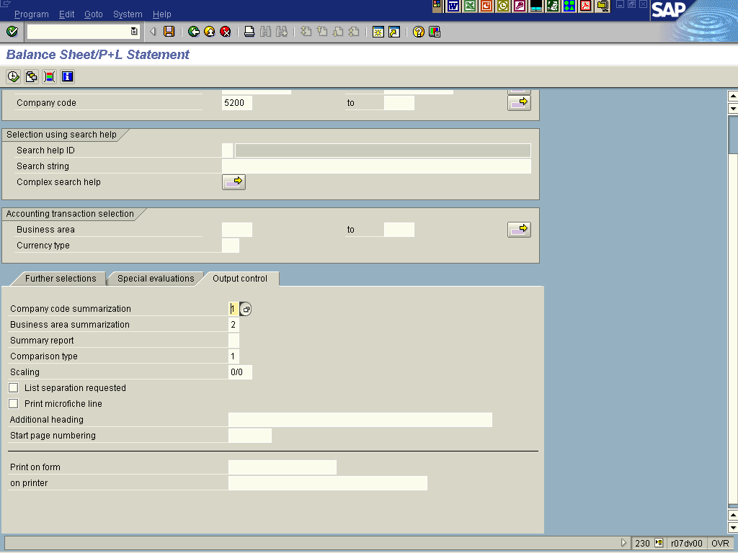

8. Click Enter Button to confirm your entries.

Balance Sheet/P+L Statement

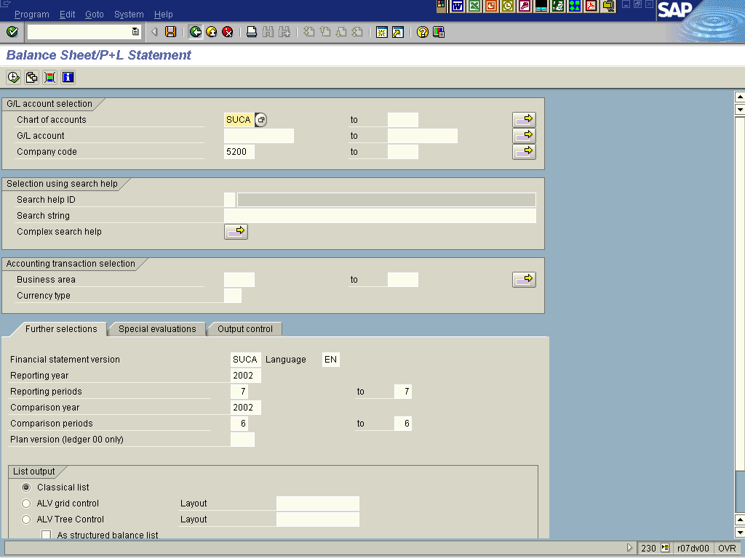

9. Press Execute button to generate a report.

Balance Sheet/P+L Statement

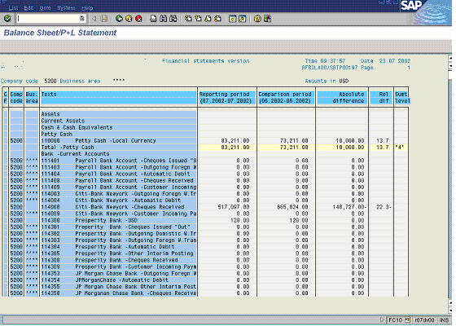

Note: You can print this report or download it as a local file. To download it, select from the menu path List -> Save -> File… and choose the required file format.

10. Click Back Button .

